Antivirus Evasion via
Source Code Injection

Introduction:
Source Code Injection is a technique for injecting malicious code, which has not been seen “In the Wild” more than a few times, when in the times that it was observed, it was powerful elements that carried out attacks against giant companies.
The idea behind Source Code Injection is to inject malicious code into part of an existing civil product code repository, during the product development phase. Since it is still in the development stage, the malicious code is bound under the legitimate code of the company and when it is compiled into a product, it will also include the malicious code, without any attention from the main developer.
The basis of the attack is that every product of such a huge company has thousands of lines of code, so that it can be assimilated without any attention from the development teams. Moreover, such a product is a complicated product, and therefore it performs a large number of operations, thus another operation will not attract any attention from the development teams and / or antivirus engines.
Because the malware is part of a known software, which usually belongs to a known giant company, the antivirus engines will exclude the software and its operations, because it is known, genuine and reliable.
Content:
Every software product produced by a huge company is signed, thus ensuring that the software is reliable software and has not been modified by a malicious entity, and therefore its actions are reliable and legitimate.
How does it work?
The way the product is signed is by the global certificate authority mechanism, where there are several specific companies that are allowed to provide signatures, and all computers rely on the signatures provided by those companies. The way to make sure that the company has indeed signed the product is through an asymmetric encryption mechanism - RSA protocol. Any such signature is signed by the company's private key and can be decrypted by the public key only. When the antivirus mechanism sees that the software is indeed signed by the global certificate authority mechanism, then it trusts the software and its operations Because it is defined as safe.

Example:
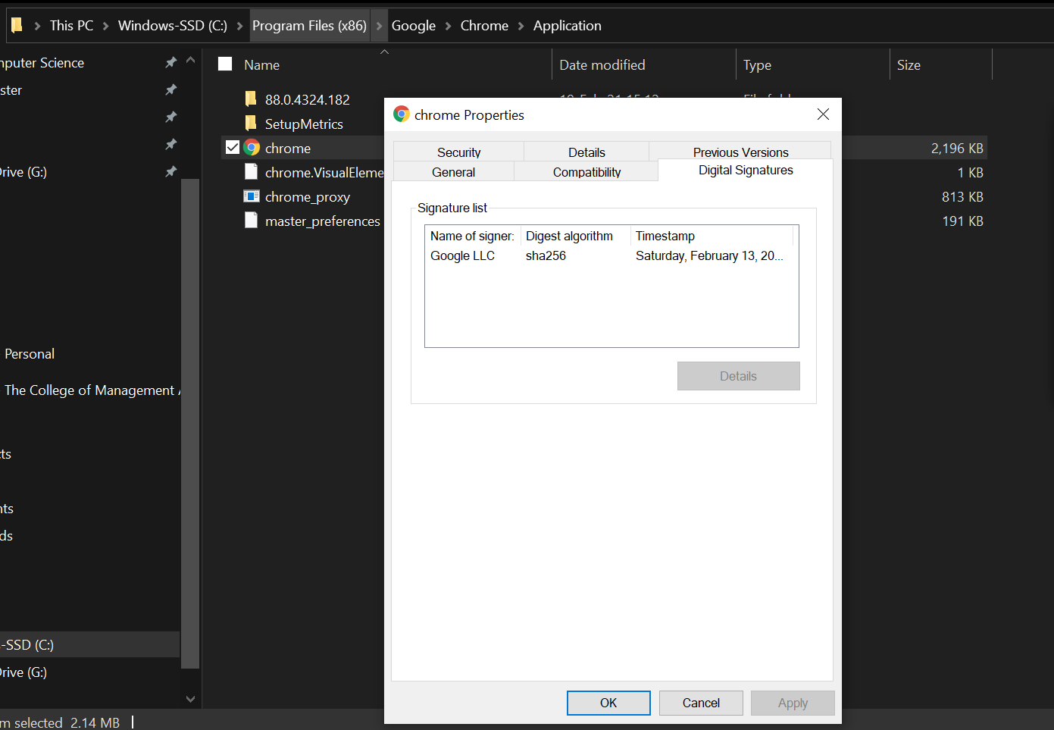
This example shows the signature of the Google Chrome software: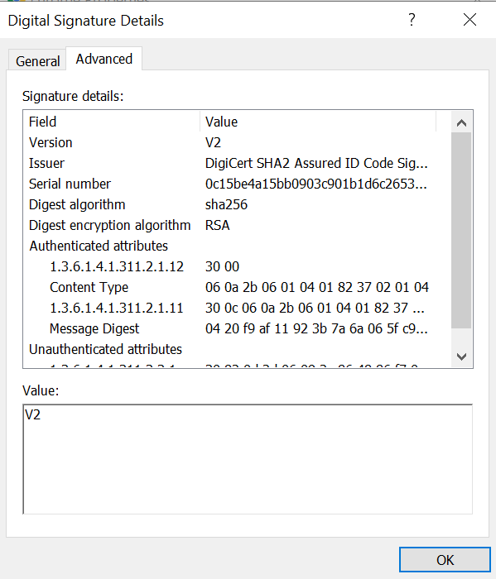
In this example it can be seen that the software is signed by a Certificate Authority called DigiCert and verified by the asymmetric encryption protocol RSA.
In addition, when the antivirus engine sees that the software is signed, it excludes it and claims that it is not malicious, even if it does things that will be identified with malware in terms of the nature of the actions, in the heuristic form.
Google Chrome, for example, uses a lot of code-injection methods for other Google Chrome processes, to enable proper management of the software.
If unsigned software behaved similarly, the antivirus engine would classify it as potentially malicious software. Moreover, even when a protective body encounters signed software, it usually classifies it as proper software and will not examine it in depth.
For example, if we upload the Google Chrome EXE file to VirusTotal.com, we will get a diagnosis of all antivirus engines on that file:
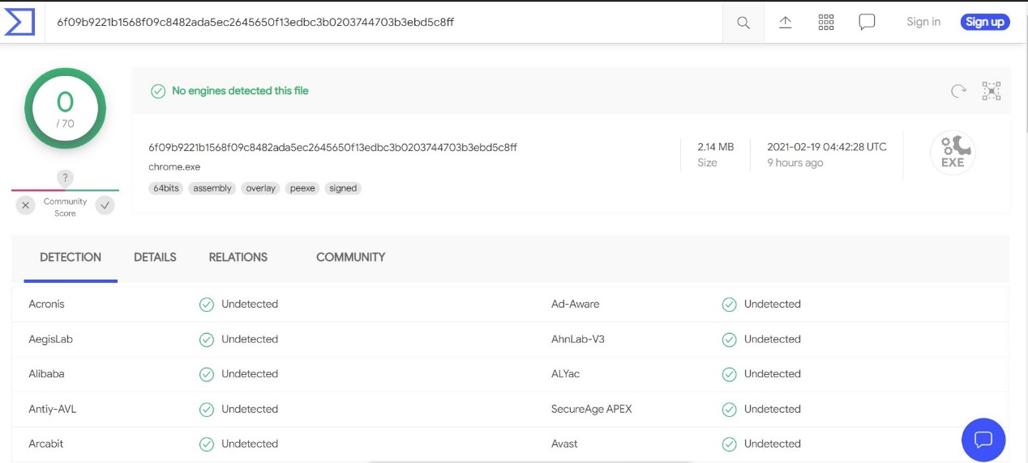

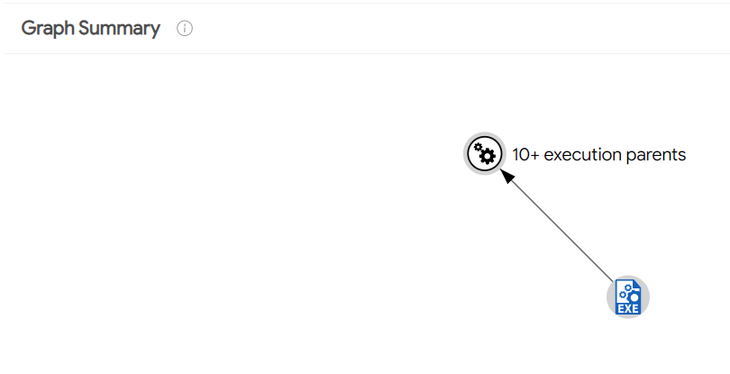
This behavior of running multiple processes in parallel on the host computer and their debug operation, is a common operation in several attacks, but is not identified here as malicious.
A famous example of this type of attack is the attack that occurred during 2020 on SolarWinds company, in which the APT system infiltrated the company with malicious code that was distributed as part of its software updates. By doing so, the attack system has gained remote access to thousands of computers, including companies and giant organizations. This attack has not been detected for a long time, as it was part of a regular software update. According to reports, behind this attack was a powerful Russian offensive line.
Summary:
Source Code Injection is an attack method for injecting malicious code, which is not well known and does not receive enough attention. With this method, it is possible to integrate malicious code within a legitimate code of a software product and thus evade the discovery of antivirus engines and / or product development teams, for a long time.
References:
https://www.solarwinds.com/sa-overview/securityadvisory
https://www.fireeye.com/blog/threat-research/2020/12/evasive-attacker-leverages-solarwinds-supply-chain-compromises-with-sunburst-backdoor.html

